**Flow from User accessing domain till the traffic reaching Azure servers**

|  |  |  |  |
| --- | --- | --- | --- |
|  | **Prepared/ Updated By** | **Reviewed by** | **Approved By** |
| **Name** | Anubhav Krishna |  |  |
| **Role** | Programmer Analyst |  |  |
| **Signature** | *Anubhav* |  |  |
| **Date** | 10/092020 |  |  |

In this documentation, we are trying to understand the flow of traffic from user accessing domain, which is hosted in our Azure infrastructure and Akamai.

This is helpful while troubleshooting any existing issue with public domains not accessible and find the point where flow is breaking.

To understand let’s take an example of a domain which is hosted both in Akamai and Azure( [www.zanussi.co.uk](http://www.zanussi.co.uk) ).

**Step 1)**

User browses the above domain [www.zanussi.co.uk](http://www.zanussi.co.uk)

Perform google dig to check if above domain hosted via Akamai

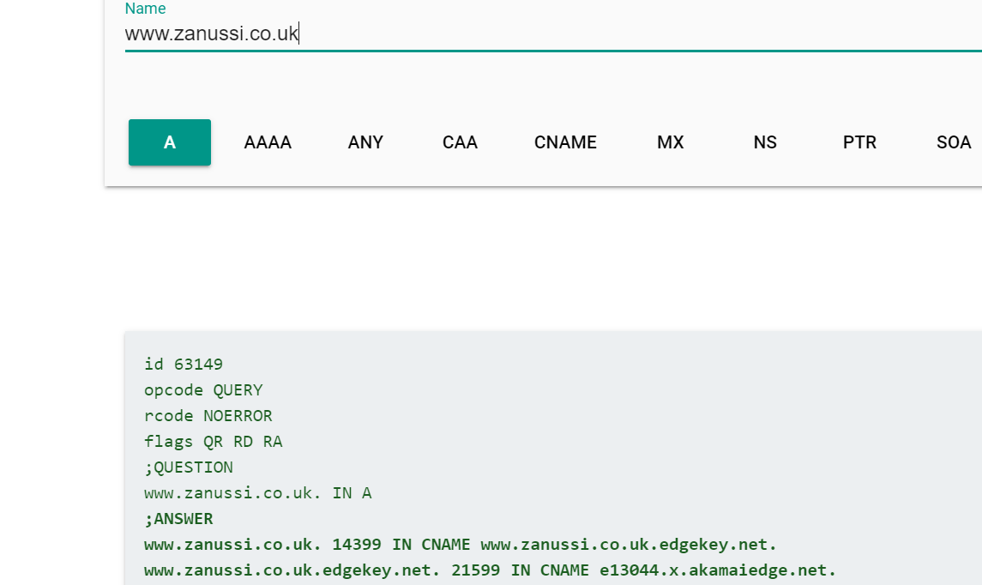

Since the CNAME ends in …edgekey.net, which confirms the site points to Akamai-

**Step 2)**

Login in to the Akamai portal and search for the property [www.zanussi.co.uk](http://www.zanussi.co.uk).

* Select the property version, which is currently active in production, and search for the default rule
* The default rule tells the next step that by Akamai adopts to move the traffic ahead , search for origin server hostname-

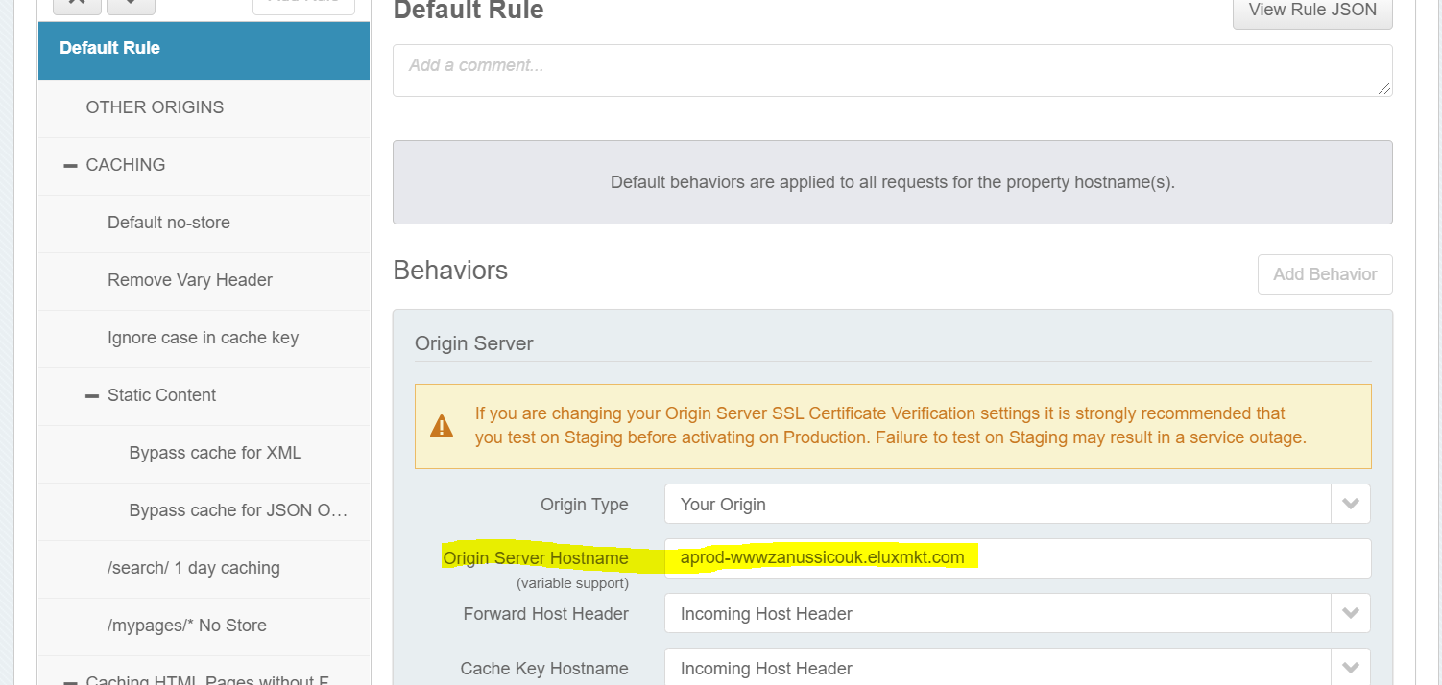

* Akamai forwards the request to the server/application gateway with help of origin hostname
* The hostname aprod-wwwzanussicouk.eluxmkt.com is the url which fetches the content directly from the server where the site is hosted.
* As per out architecture Akamai forwards the incoming host header([www.zanussi.co.uk](http://www.zanussi.co.uk)) to the azure(In general case there is one more option via origion hostname) but here only one method available in our architecture which is through incoming host header.

**Step 3)**

Perform google dig on the origin host name-

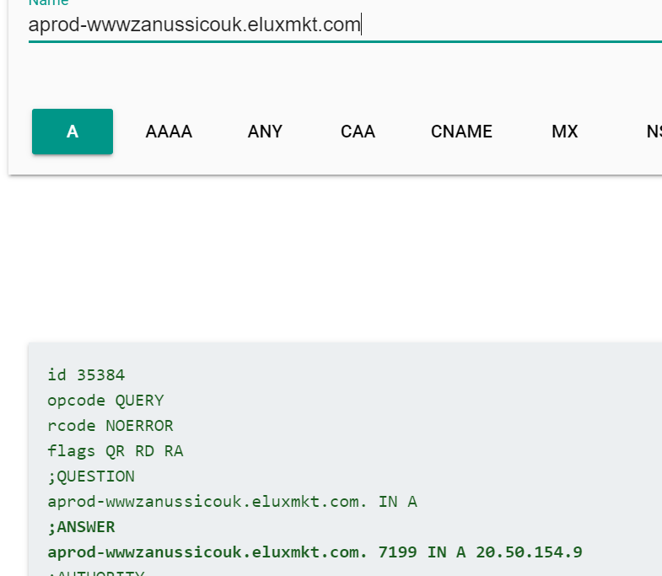

The above IP can be the IP of the load balancer /application gateway/servers.

Search for the above IP in load balancer section of the Azure portal

**Step 4)**

Traffic coming to Azure

* Azure load balancer is the first point where traffic from Akamai hits the azure
* Filter the load balancer section based on the region/location which can be found from public URL(www.zanussi.co.uk) (UK suggests Unites Kingdom under Europe)

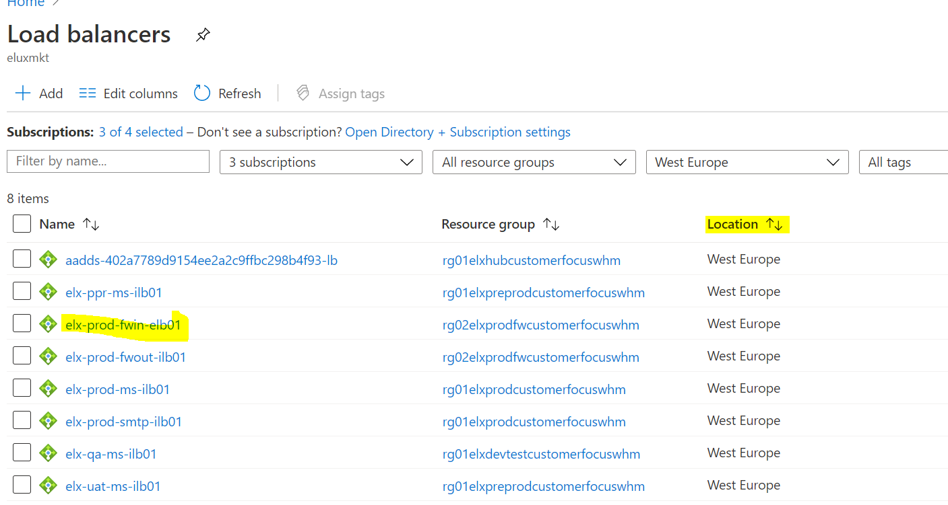

* From the above how to choose the correct load balancer-

Since it is an incoming tarffic for prod URL hence select elx-prod-fwin-elb01-

**Step 5)**

Select the appropriate load balancer from available options and click on the front end IP section of the load balancer to find the rule associated for PIP (20.50.154.9 from Step 3)

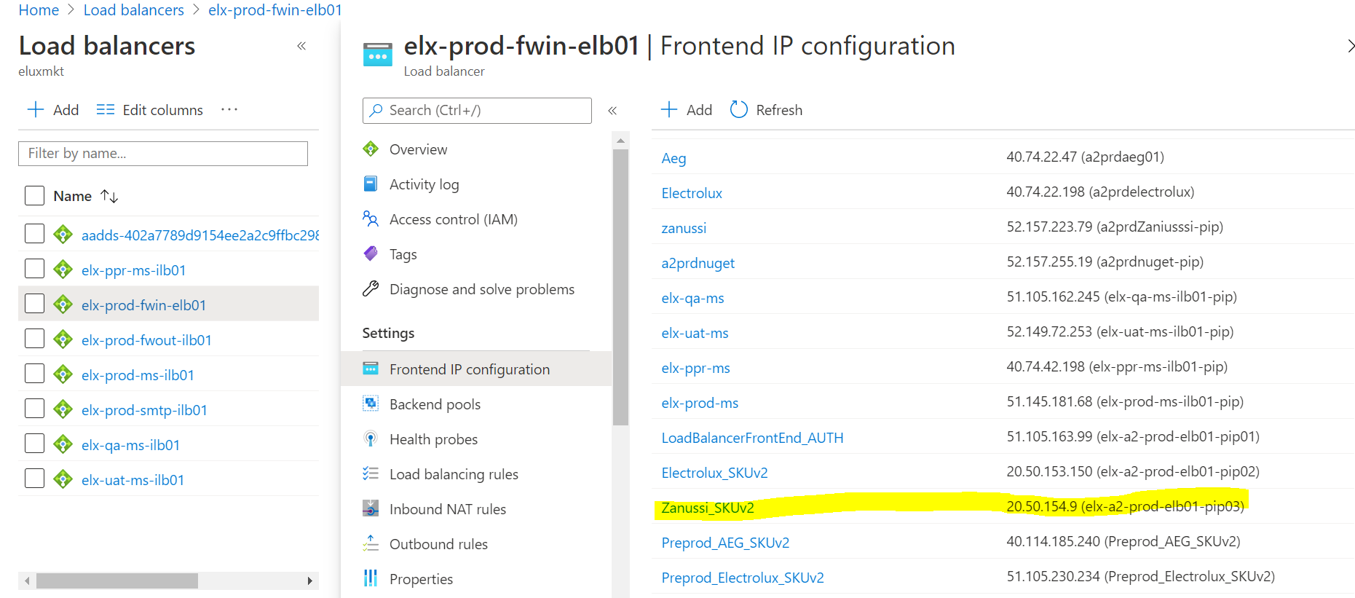

**Step 6)**

* Once traffic reaches azure load balancer, load balancer forwards the traffic to the firewall
* The below picture shows the configuration of the load balancing rule

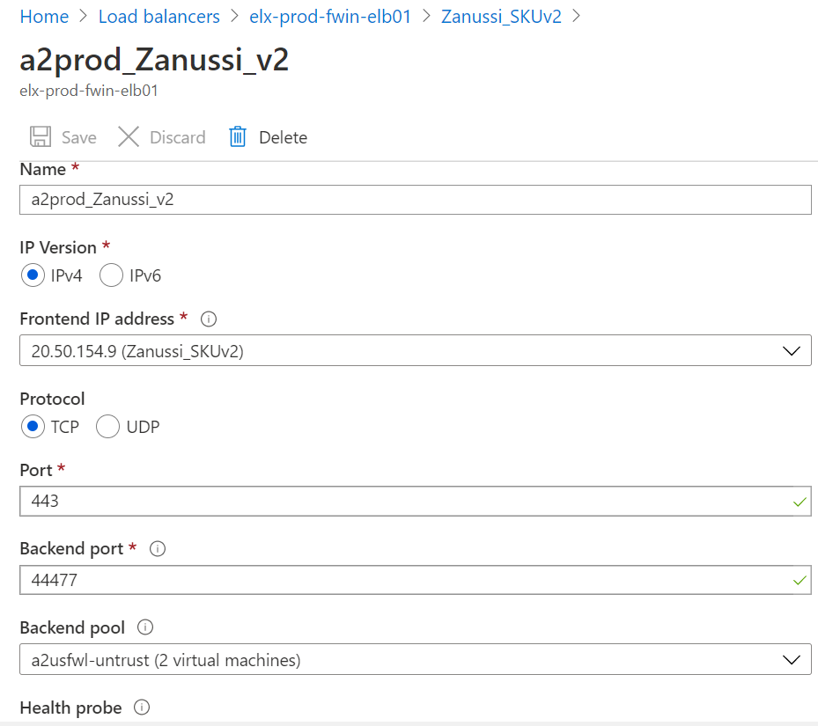

* Port 443 indicate the https protocol used(incoming traffic), port 44477 is used to forward the traffic the traffic to the respective application gateway/ server
* NAT rule comes into picture to direct the request to the appropriate application gateway/server which is configured by firewall team.
* For instance below NAT rule indicates the next stage of traffic flow which is the application gateway (from load balancer)

|  |  |  |  |  |  |  |
| --- | --- | --- | --- | --- | --- | --- |
| **Environment** | **PIP** | **Location** | **Internal Load balancer IP** | **AGW Name** | **Incoming Port** | **to Firewall** |
| PROD | 20.50.154.9 | west Europe | 10.218.1.205 | VN-ELX-GL-MKT-CUSTFOCUSWHM-PROD-EMEA-01-GTW01-ZAN | 443 | 44477 |
|  |  |  |  |  |  |  |

For different load balancer NAT rules will be different

**Step 7)**

* Search for the above application Gateway by the private IP of the Internal load balancer(in this case it is 10.218.1.205) from step 6.
* Since Akamai forwards the incoming host header(www.zanussi.co.uk) *step 2, verify whether appropriate Listener, HTTP settings and rules are present for troubleshooting any issue of request breaking

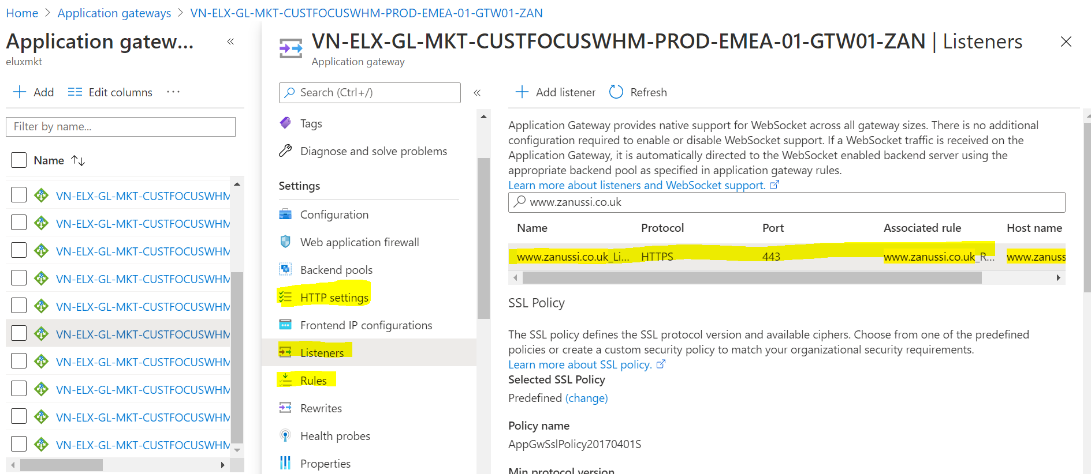

**Step 8)**

The rules section indicates backend pools in which the servers are present where the site is hosted.

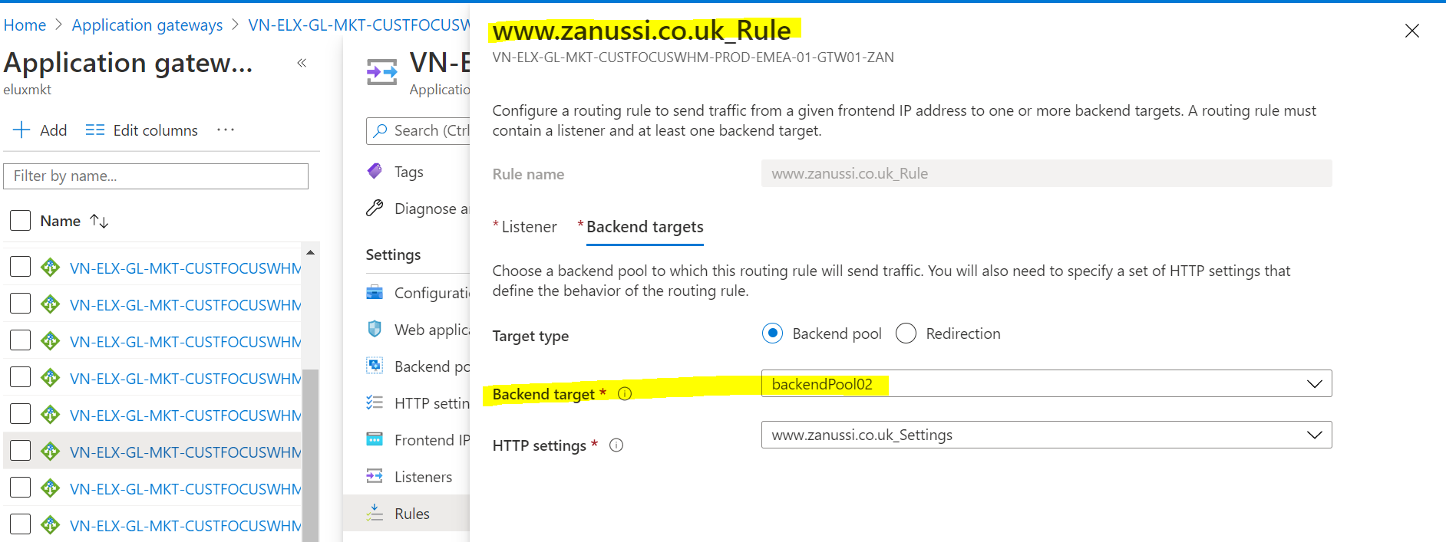

The backend pool tells us the servers

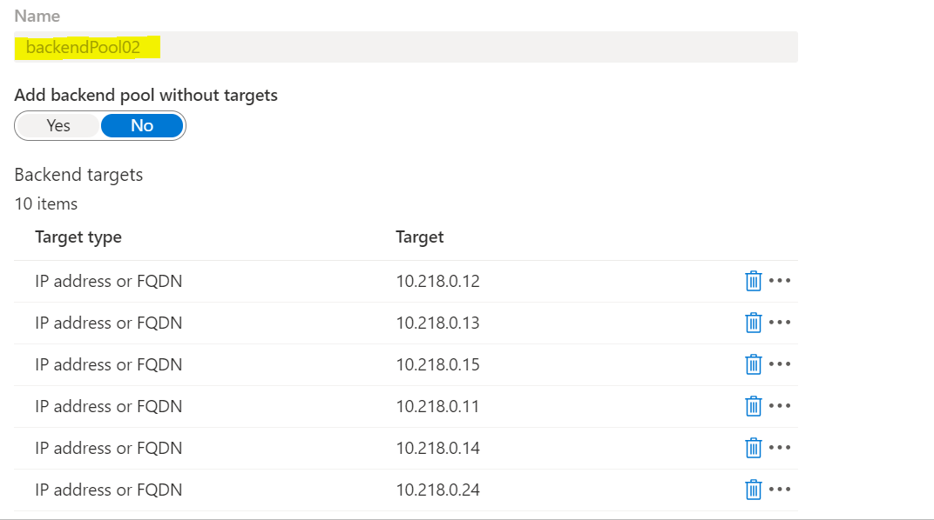

After this step we can verify whether the site is hosted/present in the servers or not and if it is working fine inside the servers by logging into the servers and checking the IIs Manger for bindings.